SOAP projects
Search “sample wsdl”

REST projects
Search “sample rest”

testRunner class → https://www.soapui.org/apidocs/5.5.0/index.html?com/eviware/soapui/model/testsuite/TestRunner.html

SEGUIR CON SESION 8
https://www.youtube.com/watch?v=GQKPClA1kBE&list=PLhW3qG5bs-L-Bt9T_bnyflQ0Te4VgFhKF&inde
x=8&ab_channel=AutomationStepbyStep

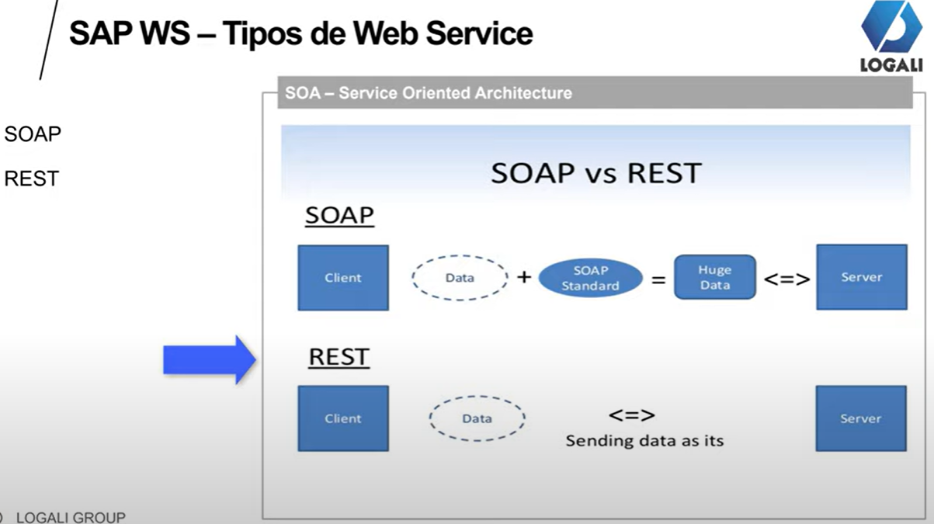

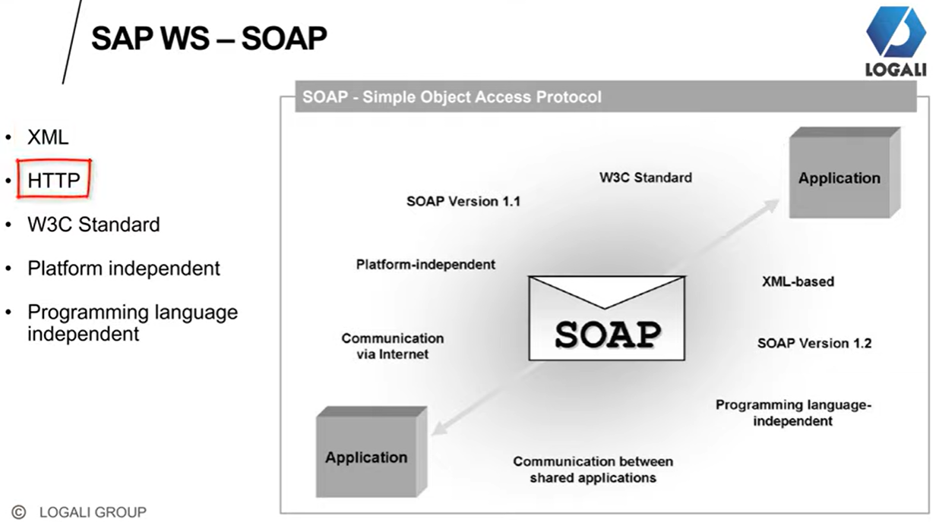

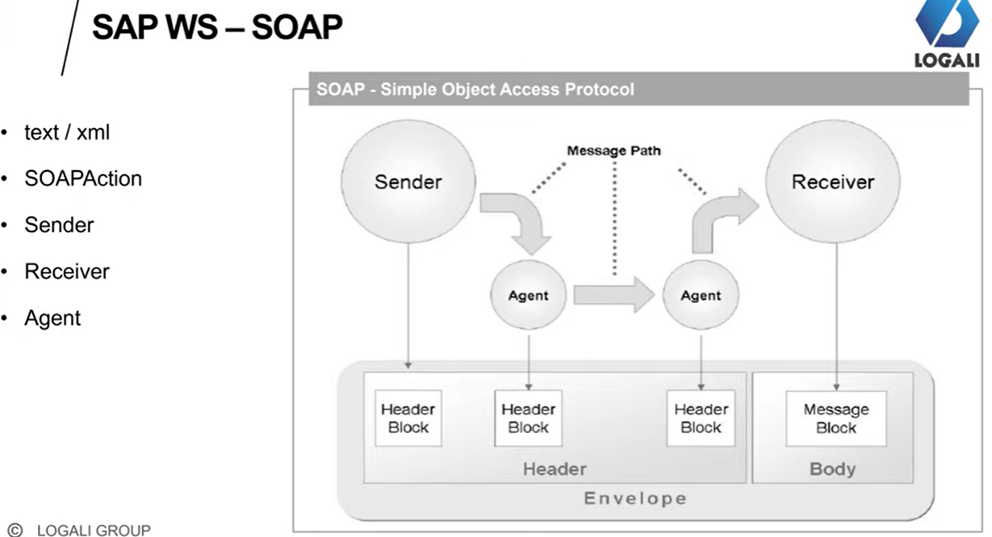
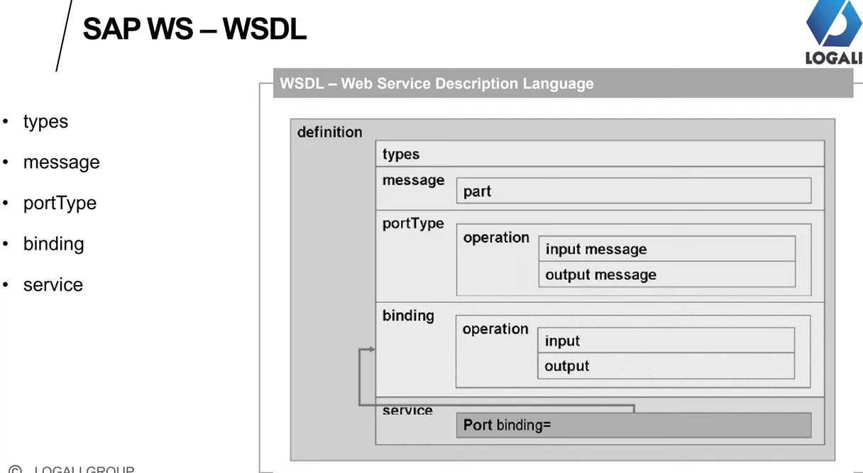

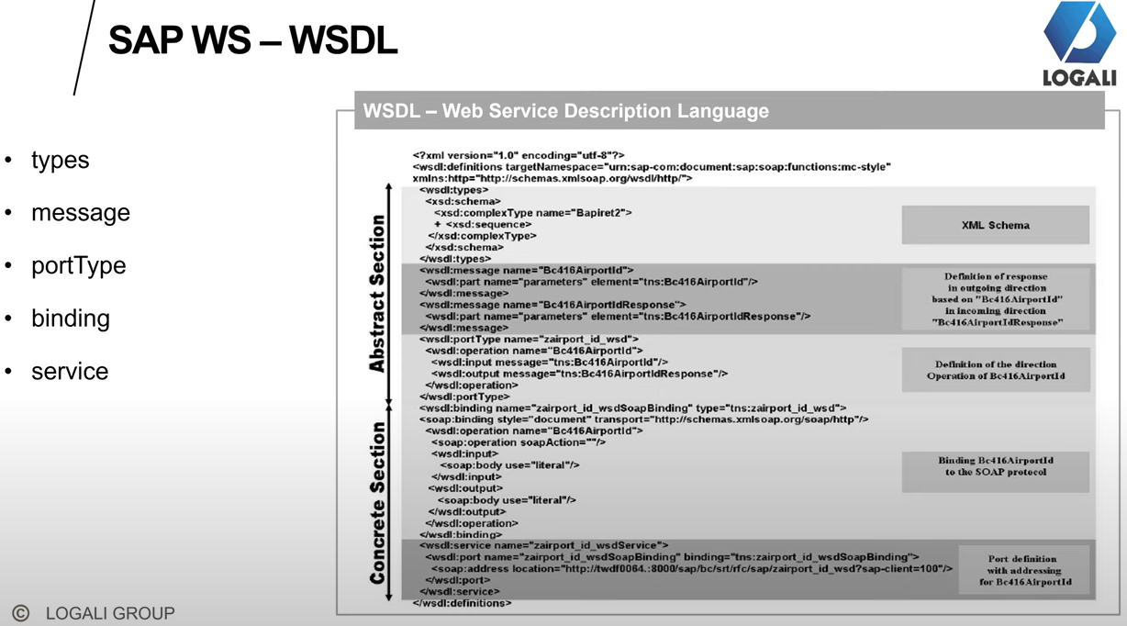

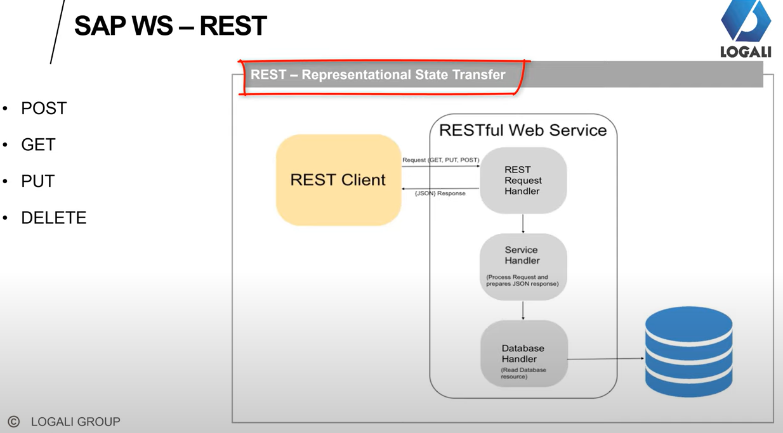

Groovy scripting https://www.youtube.com/watch?v=GQKPClA1kBE&t=6s&ab_channel=AutomationStepbyStep

//Groovy - run request from same TestCase
def status = testRunner.runTestStepByName("TestStepName")
def result = status.getStatus().toString();
log.info (" ---- "+result)

//Groovy - run request from another TestCase or TestSuite
project = testRunner.testCase.testSuite.project ;
tcase = project.testSuites["TestSuiteName"].testCases["TestCaseName"] ;
tstep = tcase.getTestStepByName("TestStepName");
def status = tstep.run(testRunner, context)
def result = status.getStatus().toString(); log.info (" ---- "+result)

//Groovy code to run test case
def tCase = testRunner.testCase.testSuite.testCases["TestCaseName"]
runner = tCase.run(new com.eviware.soapui.support.types.StringToObjectMap(), false);

//Groovy code to loop test cases in a test suite
def testCases = context.testCase.testSuite.getTestCaseList()
testCases.each{
log.info(it.name)
}

//Groovy script to run a test suite
def suite = context.testCase.testSuite.project.testSuites["TestSuiteName"]
suite.run(null,false)
// null can be replaced with : new com.eviware.soapui.support.types.StringToObjectMap()
log.info (" === "+suite.getName().toString()+" - Executed successfully")
//Groovy script to run a project
def projectName=testRunner.getTestCase().getTestSuite().getProject().getWorkspace().getProjectByName("REST Project 1")
projectName.run(null,true)
//projectName.run(new com.eviware.soapui.support.types.StringToObjectMap(), false)

groovy code to set and get setup and teardown scripts testRunner.testCase.testSuite.project.getTestSuiteByName('TestSuite1').getTestCaseByName('TestCase1').setSetupScript('log.info "setup"') testRunner.testCase.testSuite.project.getTestSuiteByName('TestSuite1').getTestCaseByName('TestCase1').setTearDownScript('log.info "teardown"')
log.info (" -- "+testRunner.testCase.getSetupScript());
log.info (" -- "+testRunner.testCase.getTearDownScript());

groovy code can be given at project load script to load setup and teardown scritps from file
def su = new File("setup.txt").text
def td = new File("teardown.txt").text
project.getTestSuiteList().each { testSuite –
testSuite.getTestCaseList().each { testCase –
testCase.setSetupScript(su)
testCase.setTearDownScript(td)
}
}

Script Assertion samples
//check response time
assert messageExchange.timeTaken 4000

//check for Endpoint
log.info messageExchange.getEndpoint()

//check for TimeTaken
log.info messageExchange.getTimeTaken()

//check for header
log.info (messageExchange.responseHeaders["Content-Length"])
assert messageExchange.responseHeaders["Content-Length"] != null

//check attachments
assert messageExchange.responseAttachments.length == 0
log.info (messageExchange.responseAttachments.length)

//validate response nodes
def groovyUtils = new com.eviware.soapui.support.GroovyUtils( context ) def requsetHolder = groovyUtils.getXmlHolder( messageExchange.requestContent ) def responseHolder = groovyUtils.getXmlHolder( messageExchange.responseContent ) def refNum = responseHolder.getNodeValue("//m:CountryCurrencyResult/m:sName") assert responseHolder.getNodeValue("//m:CountryCurrencyResult/m:sName") == "Rupees"

//to get response
def resp = messageExchange.responseContentAsXml.toString()

For JSON response
//get json response
import groovy.json.JsonSlurper
def responseMessage = messageExchange.response.responseContent
def json = new JsonSlurper().parseText(responseMessage)

//assert node values
log.info json.name
assert json.capital.toString() != null
assert json.name.toString() == "[Taiwan]"
testStepName = messageExchange.modelItem.testStep.name

//to get the Test Step Name
log.info testStepName xmlHold = messageExchange.responseContentAsXml.toString() //to store the response as Xml string

How to run from Jenkins:
https://www.youtube.com/watch?v=JLQ0ayUr4CE&list=PLhW3qG5bs-L-Bt9T_bnyflQ0Te4VgFhKF&index=18&ab_channel=AutomationStepbyStep

Jenkins download - https://jenkins.io/download/

Step 1 : Open SoapUI and goto the test case
Step 2 : Right click and select Launch Test Runner
Step 3 : Run from Test Runner and copy the commands cd C:\Program Files\SmartBear\SoapUI-5.4.0\bin\ testrunner.bat -sTestSuite1 -cAssertions "C:\Users\Raghav Pal\OneDrive\Projects\SoapUIProjects\REST-Project-1-soapui-project.xml"
Step 4 : Get Jenkins on your system
Step 5 : Run jenkins - java -jar jenkins.war --httpPort=xxxx
Step 6 : Create a new job and add details
Step 7 : Run the job and validate results

Api Monitoring
Step 1 : Open SoapUI - Right click on Project and Select - Monitor APIs
Step 2 : Connect to AlertSite (SignUp | SignIn)
Step 3 : Create Monitors
Step 4 : Add APIs to monitor and view in AlertSite

References : https://smartbear.com/lp/alertsite/fr...
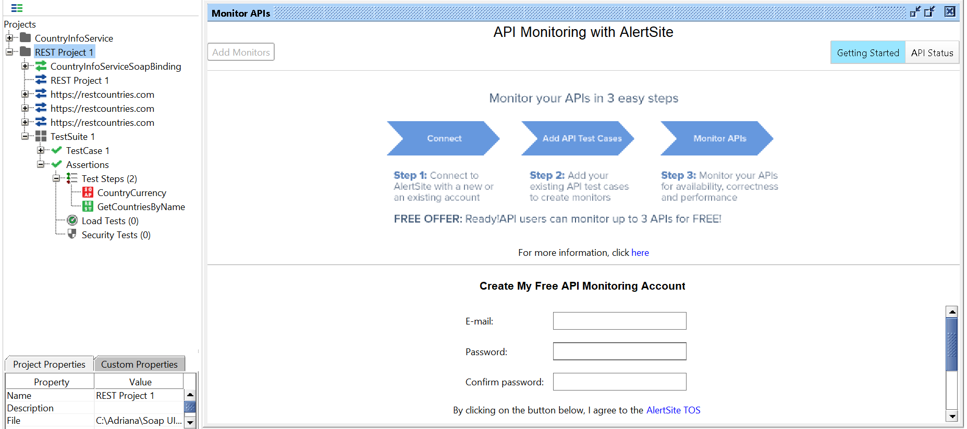

Add SoapUI Project to GIT:
Step 1 : Download and Install Git
Step 2 : Create GitHub account
Step 3 : Add SoapUI Project to Git
Goto Command Prompt
Goto location of SoapUI Project
git init
git status
git add . (“.” To add all the projects, or only the name of the project you want to add )
git commit -m "commit message"
git push -u url master
Step 4 : Validate changes are pushed to repository
Step 5 : Remove project from Git

